**Diagram Explanation**

1. **High-Level Architecture Diagram**: Shows a simplified view of the data flow from the Raspberry Pi to various AWS services.
2. **Detailed Sequence Flow Diagram**: Describes the sequential interactions between components, highlighting how data moves through the system.
3. **AWS Service Interaction Diagram**: Provides an overview of the main AWS services involved in the system and how they interact.
4. **Component Diagram with Roles and Permissions**: Displays the specific AWS services, their interactions, and the IAM roles involved, illustrating the access permissions required.
5. **Data Flow and Processing Diagram**: Focuses on the movement and processing of data, emphasizing the key actions performed by each component.

**1. High-Level Architecture Diagram**

**graph** TD

    A[Raspberry Pi] **-->**|Publish Sensor Data| B[AWS IoT Core]

    B **-->** |Trigger Rule| C[AWS Lambda]

    C **-->** |Store Data| D[DynamoDB]

    C **-->** |Save File| E[S3 Bucket]

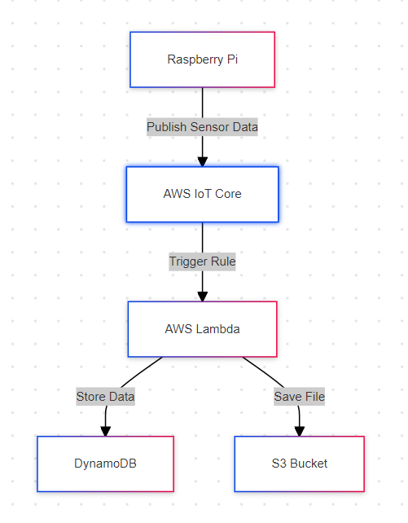

**2. Detailed Sequence Flow Diagram**

**sequenceDiagram**

    participant Pi as Raspberry Pi

    participant IoT as AWS IoT Core

    participant Lambda as AWS Lambda

    participant DB as DynamoDB

    participant S3 as S3 Bucket

    Pi**->>**IoT**:** Publish Sensor Data (MQTT)

    IoT**->>**Lambda**:** Trigger Lambda via Rule

    Lambda**->>**DB**:** Insert Data into DynamoDB

    Lambda**->>**S3**:** Upload JSON File to S3

    S3**->>**Lambda**:** Confirm Upload

    DB**->>**Lambda**:** Confirm Data Storage

    Lambda**->>**IoT**:** Processing Acknowledgement

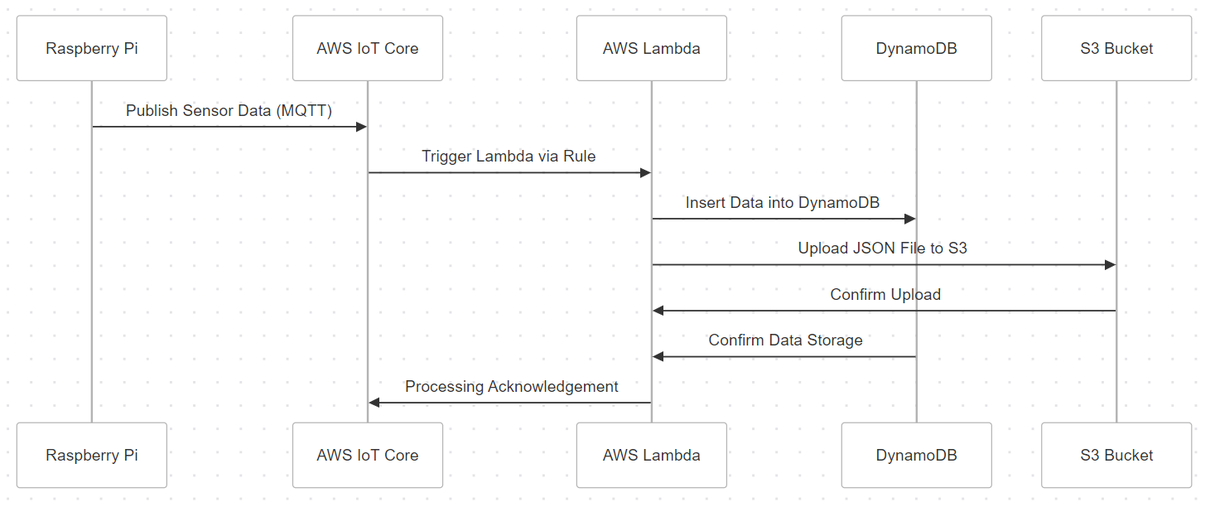

**3. AWS Service Interaction Diagram**

**graph** LR

**subgraph** AWS Cloud

        IoT[AWS IoT Core]

        Lambda[AWS Lambda]

        DB[DynamoDB]

        S3[S3 Bucket]

**end**

    Pi[Raspberry Pi] **-->**|MQTT| IoT

    IoT **-->** |Invoke| Lambda

    Lambda **-->** |Store| DB

    Lambda **-->** |Upload| S3

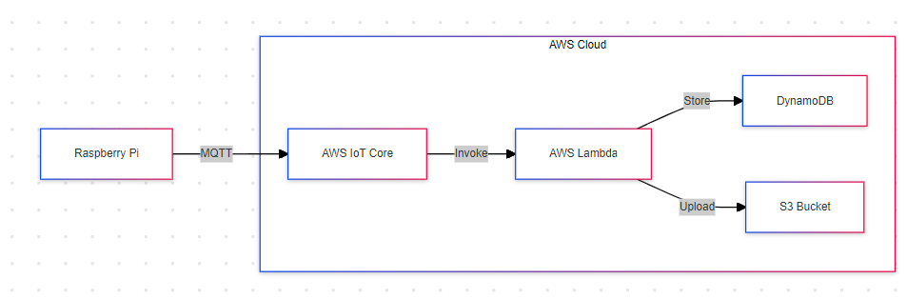

**4. Component Diagram with Roles and Permissions**

**graph** TD

**subgraph** AWS

        direction LR

        IoTCore[AWS IoT Core]

        LambdaFn[AWS Lambda]

        S3Storage[S3 Bucket]

        DynamoDBTable[DynamoDB]

        IAMRoleLambda[IAM Role: Lambda]

        IAMUser[IAM User: RaspberryPiUser]

**end**

    RaspberryPi **-->**|MQTT Publish| IoTCore

    IoTCore **-->** |Trigger| LambdaFn

    LambdaFn **-->** |Store Data| DynamoDBTable

    LambdaFn **-->** |Upload File| S3Storage

    IAMUser **-->** |Policies| IoTCore

    IAMRoleLambda **-->** |Permissions| LambdaFn

    IAMRoleLambda **-->** |Access| S3Storage

    IAMRoleLambda **-->** |Access| DynamoDBTable

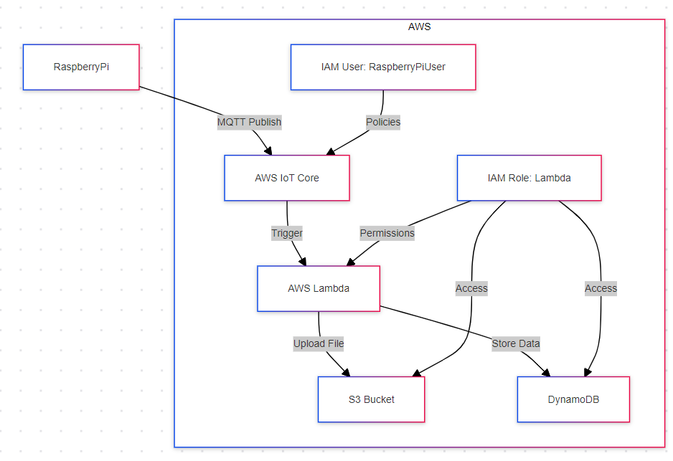

5. Data Flow and Processing Diagram

**flowchart** TB

    Pi[Raspberry Pi]

    IoT[AWS IoT Core]

    Lambda[AWS Lambda]

    Dynamo[DynamoDB]

    S3[S3 Bucket]

    Pi **-->** |Send Data| IoT

    IoT **-->** |Trigger Function| Lambda

    Lambda **-->** |Store Data| Dynamo

    Lambda **-->** |Upload Data| S3

